1) Login option to see data from all branches, aka reporter role
Branch work is based on Security Strategy Complex.
Depending on the “Read Mode” flag, access permissions to branch data are determined.
We cannot say exactly what the change in the logic of the Branches (configurable "Read Mode" per user) can lead to.
There may be problems with data security and more.
I can say for sure that these changes will not be carried out as part of the Xafari framework.
You can order a revision as part of your project. To do this, you need to contact nataly.putrenko@galaktika-soft.com.

2) Users that need to see data from multiple branches without knowing it
The Branches has an automatic login feature. You can enable it in the configuration editor (XAS). You need to set the LogOnAutomaticly flag to true.
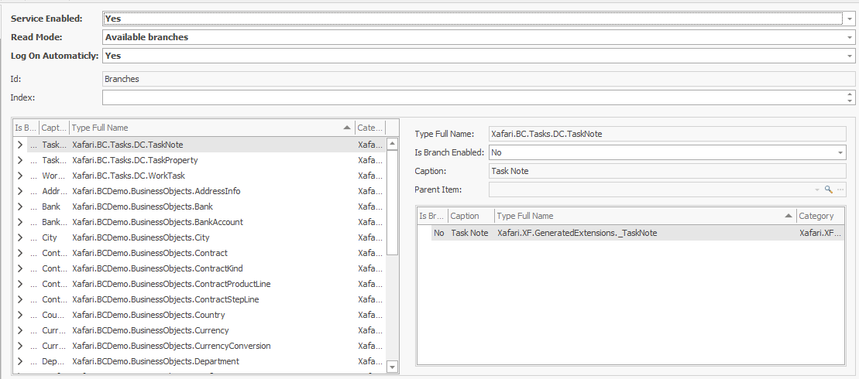
In this case, a window with a branch selection will not be called up.
If the user has access to only one branch, then the user will automatically work under this branch.
If there are several, then the system will select the first available branch that has write permissions.

